**Creating Savings Action**

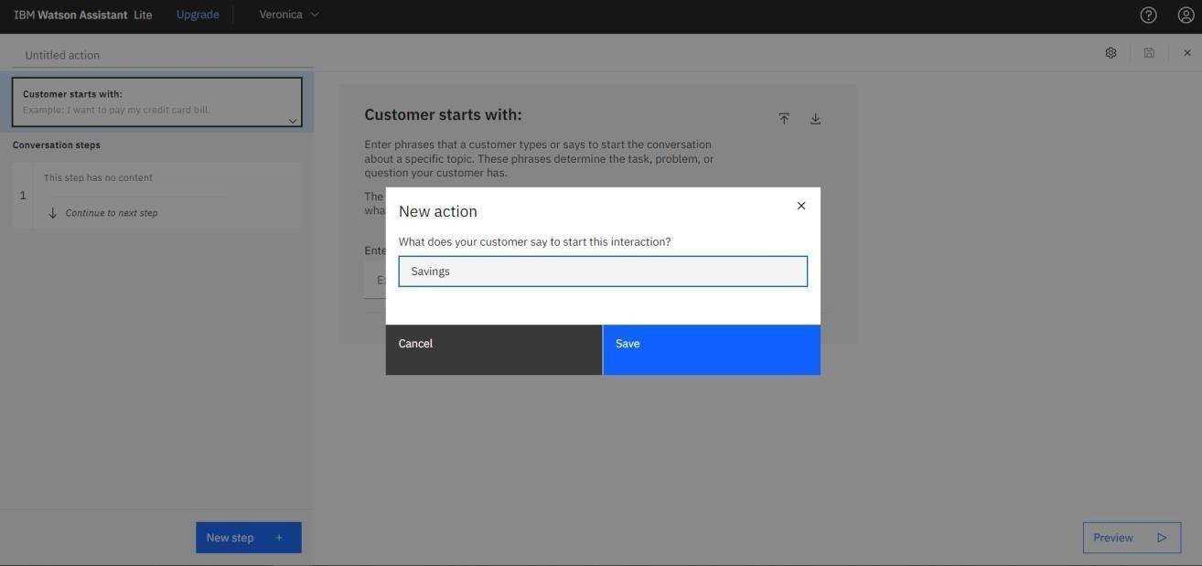

In this step, we are adding steps in Savings Action to handle customer queries regarding Regular Savings Account, Kids Savings Account and Zero - Balance Account creation.

